GOVT. DIGVIJAY PG AUTONOMOUS COLLEGE RAJNANDGAON (C.G.)
DEPARTMENT OF GEOGRAPHY
MoU ACTIVITY 2023-24
Department of Geography, Govt. Digvijay PG Autonomous College Rajnandgaon (C.G.) organized MA (Geography) Students’ Centric One Week Workshop on Remote Sensing (RS) and Geographic Information System (GIS) from 04-10-2023 to 11-04-2023 in the Computer Science Lab. of the college. Its timing was from 11.00AM to 1.00 PM for the presentation by the Resource Person and from 2.00 PM to 4.00 PM for the Practical Work by the students with the help of Resource Persons.

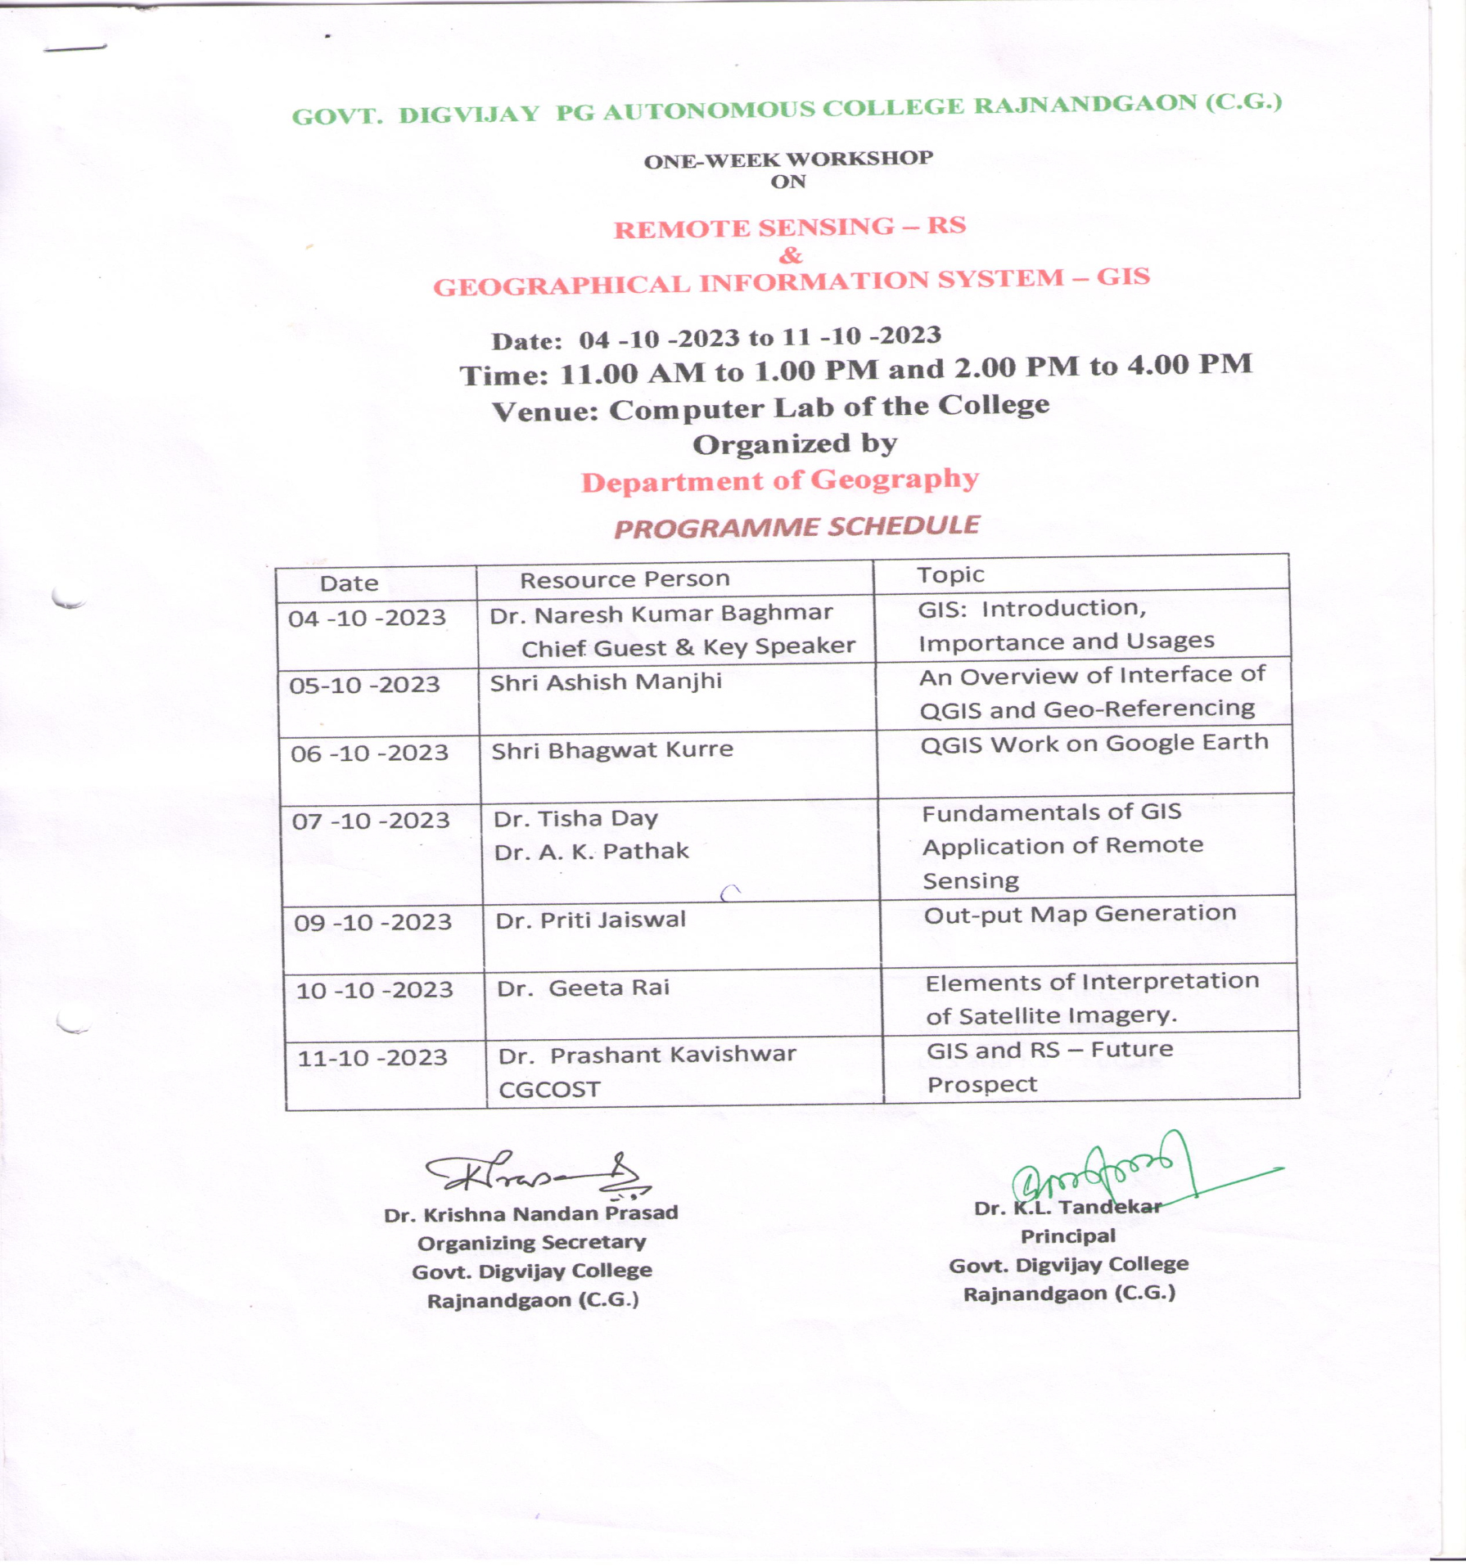

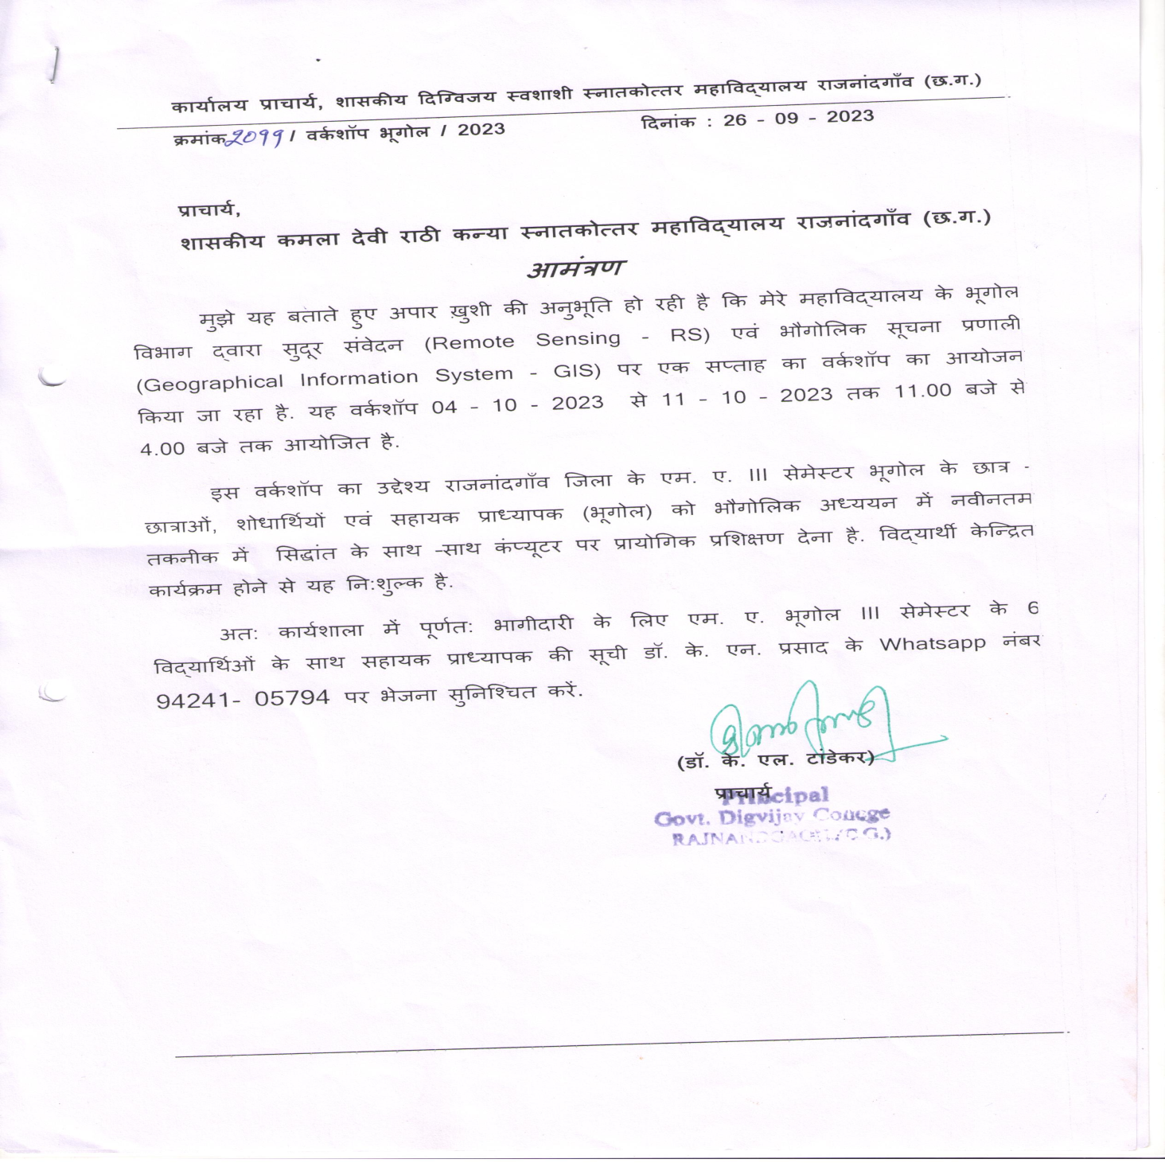
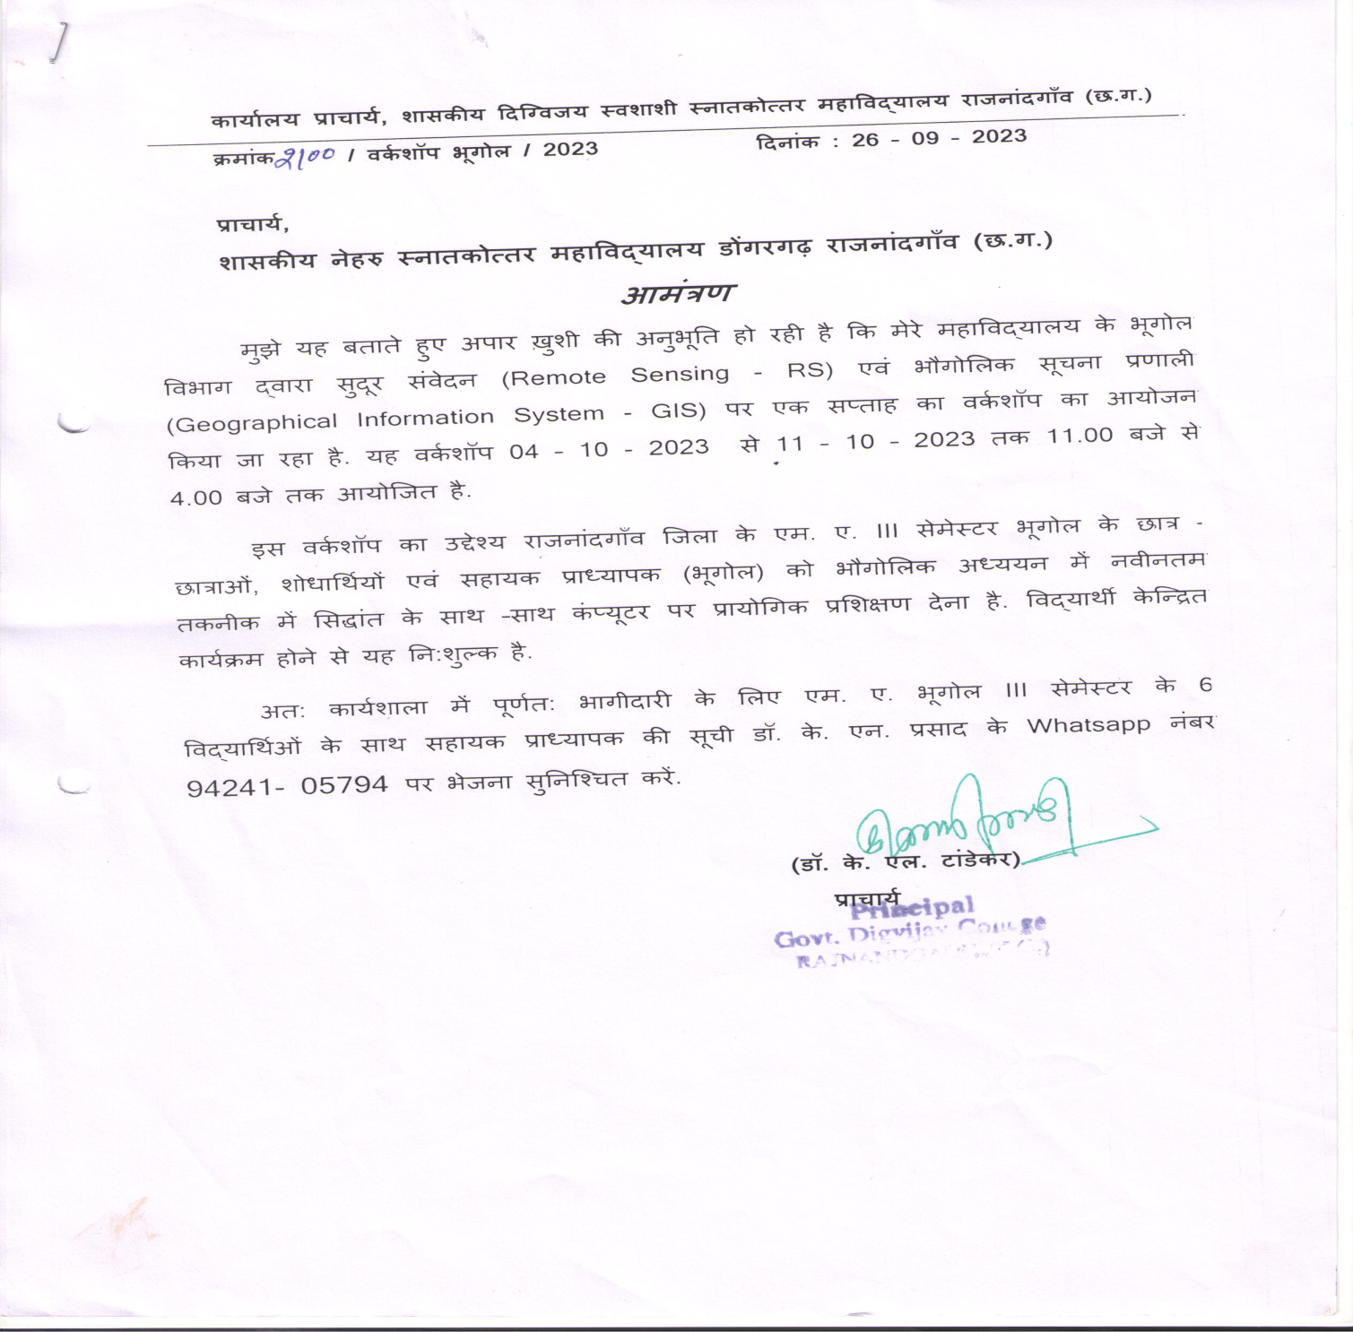

Digvijay College has MoU with the following two PG colleges of Rajnandgaon District -
- Govt. Kamla Devi Rathi Girls PG College Rajnandgaon
- Govt. Nehru PG College Dongargarh, Rajnandgaon
So, it arranged free of cost participation of some selected MA III semester students and Asst. professors from these colleges. Their list and geo-tagged photographs are enclosed herewith.
- Govt. Kamla Devi Rathi Girls PG College Rajnandgaon
- Dr. K. K. Dwivedi, Asst Professor
- Ku. Harsha Sinha
- Ku. Garima
- Ku. Kanti Verma
- Ku. Veenita
- Ku. Kavita Koma
- Ku. Yamuna Sahu
- Govt. Nehru PG College Dongargarh, Rajnandgaon
- Shri H. R. Padme, Asst Professor
- Ku. Savita Devangan
- Ku. Pramila Verma
- Ku. Namrata Khare
- Ku. Tomeshwari Verma
- Ku. Chetan Kanwar
- Ku. Yamuna Sahu
- Ku. Divya Namdeo
- Ku. Ritu Patel
- Shri Mukul mahobia

